Hands-on 8: Persistent & Modular Database Systems

1. Prerequisites
- Terminal Access: Open your VS Code terminal.
- Knowledge Check: This lab combines Structs, Interfaces, HTTP, and SQL Persistence.

2. Why are we doing this?
In a professional environment, putting 1,000 lines of code in one main.go file makes it impossible to maintain or test. By splitting the code into Packages, we ensure:
- Separation of Concerns: The Web Server doesn't need to know how SQL works.
- Scalability: We can add new features without breaking existing ones.
- Persistence: Your data survives even if the server crashes or restarts.

3. Step 1: Project Environment Setup
Run these commands to create a clean, modular environment.
# 1. Create the project root directory
mkdir 08_modular_db_lab
cd 08_modular_db_lab
# 2. Initialize the Go module (we will use 'task-app' as the import name)
go mod init task-app
# 3. Download the SQLite Driver
go get modernc.org/sqlite

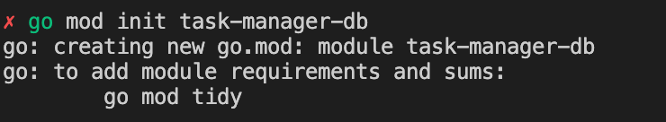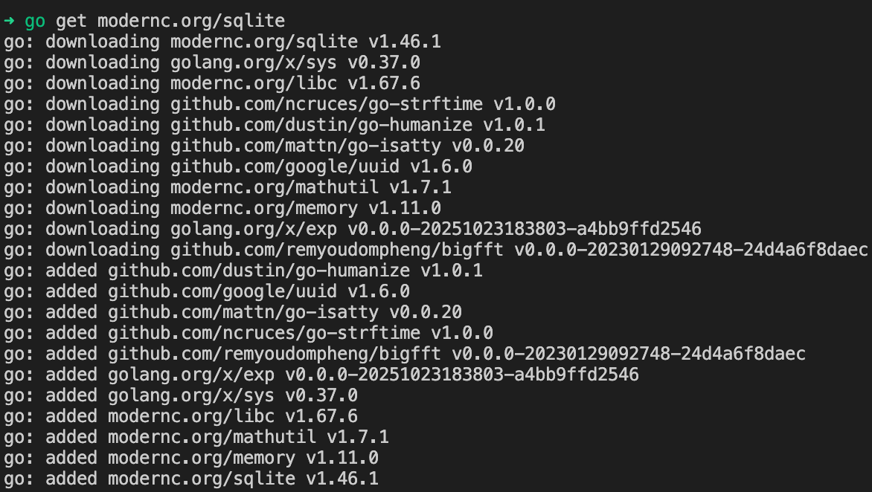

# 4. Create the sub-package folders
mkdir models
mkdir repository

4. Step 2: Coding the Architecture

File A: models/task.go
This defines the data "Blueprint."
package models
// Task represents the data structure for our database and JSON
type Task struct {
ID int `json:"id"`
Title string `json:"title"`
Done bool `json:"done"`
}

File B: repository/db.go
The "Data Access Layer." This file owns all SQL interactions.
package repository
import (
"database/sql"
"task-app/models"
_ "modernc.org/sqlite" // Essential: Registers SQLite driver
)
type TaskRepo struct {
DB *sql.DB
}
// NewRepo initializes the repository with a database connection
func NewRepo(db *sql.DB) *TaskRepo {
return &TaskRepo{DB: db}
}
// GetAll fetches every task from the SQLite file
func (r *TaskRepo) GetAll() ([]models.Task, error) {
rows, err := r.DB.Query("SELECT id, title, done FROM tasks")
if err != nil {
return nil, err
}
defer rows.Close()
var tasks []models.Task
for rows.Next() {
var t models.Task
rows.Scan(&t.ID, &t.Title, &t.Done)
tasks = append(tasks, t)
}
return tasks, nil
}
// Save inserts a new task and updates the struct with the new ID
func (r *TaskRepo) Save(t *models.Task) error {
query := "INSERT INTO tasks (title, done) VALUES (?, ?)"
res, err := r.DB.Exec(query, t.Title, t.Done)
if err != nil {
return err
}
id, _ := res.LastInsertId()
t.ID = int(id)
return nil
}

File C: main.go
The "Orchestrator." It wires the Database to the Repository and starts the Web Server.
package main
import (
"database/sql"
"encoding/json"
"fmt"
"log"
"net/http"
"task-app/models"
"task-app/repository"
)
var repo *repository.TaskRepo
func handleTasks(w http.ResponseWriter, r *http.Request) {
w.Header().Set("Content-Type", "application/json")
switch r.Method {
case http.MethodGet:
tasks, err := repo.GetAll()
if err != nil {
http.Error(w, "Database error", http.StatusInternalServerError)
return
}
json.NewEncoder(w).Encode(tasks)
case http.MethodPost:
var t models.Task
if err := json.NewDecoder(r.Body).Decode(&t); err != nil {
http.Error(w, "Invalid JSON", http.StatusBadRequest)
return
}
if err := repo.Save(&t); err != nil {
http.Error(w, "Could not save task", http.StatusInternalServerError)
return
}
w.WriteHeader(http.StatusCreated)
json.NewEncoder(w).Encode(t)
default:
http.Error(w, "Method not allowed", http.StatusMethodNotAllowed)
}
}
func main() {
// 1. Initialize SQLite connection
db, err := sql.Open("sqlite", "tasks.db")
if err != nil {
log.Fatal(err)
}
// 2. Create schema
db.Exec("CREATE TABLE IF NOT EXISTS tasks (id INTEGER PRIMARY KEY AUTOINCREMENT, title TEXT, done BOOLEAN)")
// 3. Dependency Injection: Pass DB to Repository
repo = repository.NewRepo(db)
// 4. Set up routes and start server
http.HandleFunc("/tasks", handleTasks)
fmt.Println("🚀 Modular Persistent API running at http://localhost:8080/tasks")
log.Fatal(http.ListenAndServe(":8080", nil))
}

5. Execution & Verification
- Run the project: go run main.go
- Check your go.mod file
- Open your go.mod file in the root directory. It must look exactly like this: module task-app
- Test with CURL (Terminal 2):
# Add a task
curl -X POST -d '{"title": "Complete Go Intensive", "done": true}' http://localhost:8080/tasks
# Retrieve tasks
curl http://localhost:8080/tasks

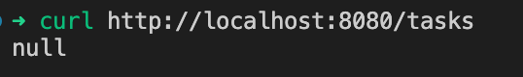

In Go, a slice that is declared but not initialized is nil. When json.Encoder encounters a nil slice, it converts it to the literal string null

To see data, you must first send a POST request to write data into your tasks.db file.

Step: Insert Data Run this in your terminal:
curl -X POST -H "Content-Type: application/json" -d '{"title": "Mastering Go Modules", "done": false}' http://localhost:8080/tasks

Now run the GET request:
curl http://localhost:8080/tasks

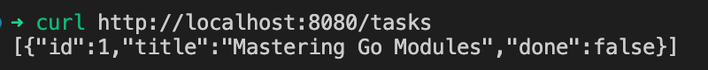

To see the database "working" in real-time, try this:

Open your terminal.

Run ls -lh tasks.db

Add 10 tasks via curl.

Run ls -lh tasks.db again. The file size will grow. That is the physical showcase of your data being saved.

6. Checklist of Accomplishments
- [ ] Clean Architecture: Separated concerns into models and repository.
- [ ] Dependency Injection: Passed the *sql.DB into a custom repository struct.
- [ ] Parameterized Queries: Used ? to prevent SQL Injection.
- [ ] Persistent Storage: Data is saved in a physical tasks.db file.
- [ ] REST Implementation: Handled different HTTP verbs with correct status codes.

7. Strategic Conclusion
You have successfully transitioned from a beginner to a Go Backend Engineer.
Over these 8 modules, you have learned that Go’s strength lies in its simplicity and explicitness. You don't hide your database logic inside a massive framework; you build it clearly using the standard library. This modular approach is exactly how large-scale microservices are built at companies like Netflix, Uber, and Twitch.
You now possess the skills to build a complete, end-to-end system: from the raw data in a database to a concurrent web API served to the world.

